Knowledge, attitude and practices towards coronavirus disease (COVID- 19) in Southeast and South Asia: a mixed study design approach
Mohammad Meshbahur Rahman¹, Roy Rillera Marzo^{2,3,4}, Shanjida Chowdhury⁵, Mohammad Nayeem Hossain⁶, Gowranga Kumar Paul⁷, Khadijah Abid Khan⁸, Wegayehu Enbeyle Sheferaw^{9,} Angela A/P Mariadass³, Divitra A/p Chandran³, Shasvini A/P Kanan³, Ahmad Umar Shafie Bin Ahmad Firdaus³, Fatimah Az Zahra’ binti Sabarin³, Sikandar Ali Qalati¹⁰

¹World University of Bangladesh, Dhaka, Bangladesh. meshbah037@gmail.com
²Department of Community Medicine, International Medical School, Management and Science University, Selangor, Malaysia
³Department of Community Medicine, Faculty of Medicine, Asia Metropolitan University, Johor, Malaysia; rrmtexas@yahoo.com; angeladass99@gmail.com; chandrandivitra2@gmail.com; shasvinikanan18@gmail.com; shafie20a@gmail.com; timahtingtangting13@gmail.com
⁴ Global Public Health, Jeffrey Cheah School of Medicine and Health Sciences, Monash University Malaysia
⁵Department of General Educational Development, Daffodil International University, Bangladesh. Email: Shan_chydiu.ged@daffodilvarsity.edu.bd
⁶Department of Statistics, Shahjalal University of Science and Technology, Sylhet, Bangladesh
⁷Department of Statistics, Mawlana Bhashani Science and Technology University, Santosh, Tangail-1902, Bangladesh
⁸Department of Public Health, The Shaheed Zulfikar Ali Bhutto Institute of Science and Technology, Karachi, Pakistan; email: khadijahabid@gmail.com
⁹Department of Statistics, Mizan-Tepi University, Tepi, Ethiopia; wegayehu.info@gmail.com
¹⁰School of Finance and Economics, Zhenjiang City, Jiangsu Province, Jiangsu University, China; sidqalati@gmail.com
Abstract
Coronavirus has spread to almost every country since its emergence in Wuhan, China and countries have been adopted an array of measures to control the rapid spread of the epidemic. Here, we aimed to assess the person’s knowledge, attitude and practices (KAP) towards the COVID-19 epidemic in Southeast and South Asia applying the mixed study design (cross-sectional and systematic review). In the cross-sectional study, respondents’ socio-demographic and KAP-related information was collected through an online population-based survey from the Malaysian population. In the systematic review, the database PubMed, Web of Science and Google Scholar search engine were searched and related published articles from South and Southeast Asia were included. Frequency distribution, Chi-square association test and binary logistic regression were fitted using cross-sectional data whereas random effect model and study bias were performed in meta-analysis. As of 743 respondents, the prevalence of good knowledge, positive attitude and frequent practice towards COVID-19 epidemic were found 52.6%, 51.8% and 57.1%, respectively. The KAP prevalence were ranged from 26.53 (Thailand) to 95.4% (Nepal); 59.3 (Turkey) to 92.5% (Pakistan); and 50.2 (Turkey) to 97% (Afghanistan), respectively, obtained by 18 studies included in the meta-analysis. The prevalence of KAP was higher in South Asia compared to Southeast Asia, obtained by subgroup analysis. Some studies reported mean level instead of the proportion of the KAP where the score varied from 8.15-13.14; 2.33-33.0; and 1.97-31.03, respectively. The study reveals that having more knowledge and attitude were encourage more likely to practice towards COVID-19. Our mixed study suggests age, gender, education, place of residence and occupation as the most frequent significant risk factors of knowledge, attitude and practice. The study also informs how other countries in Southeast and South Asia enriches their knowledge during the pandemic which may help health professionals and policymakers to develop targeted interventions and effective practices.

Keywords: COVID-19; knowledge; attitude; practice; Southeast and South Asia

Introduction
On 11th March 2020, the World Health Organization [WHO] declared coronavirus (COVID-19) to be a global pandemic [1]. The virus has spread to almost every country since its emergence in Wuhan, China [2–4]. As of 7th September 2021, worldwide, 221.93 million cases and 4.59 million deaths have been confirmed, whereas only 5.6 billion vaccines have been reported by the WHO. In Asia and Southeast Asia, over 71.96 million and 37.34 million confirmed cases has been respectively [5]. On 25th January 2020, Malaysia reported the first coronavirus case [6]. On 17 March 2020, the first two COVID-19 deaths were confirmed by the Malaysian government [7]. As of 11th September 2021, Malaysia has experienced 1.92 million positive cases, including 19,486 deaths [8].

The WHO suggested various strategies and measures such as social distancing, using sanitizers, wearing masks, regular handwashing and avoid visiting crowded places to prevent the spread of disease, and based on WHO suggestion, most of the countries started lockdowns [9]. Although, the lockdowns decision was not easy for the developing counties as it affected people and countries' economic performance very badly. For example- in a study, the Fernades (2020), estimated about a 10–15% decrease in the GDP of 30 countries [10]. However, in order to mitigate the large-scale population spread of COVID-19 and to reduce the pressure on the country’s health facilities, the Government of Malaysia launched the "Movement Control Order (MCO)" on 18th March 2020 [1]. Same as the lockdowns in other Southeast and South-Asian countries, the MCO prohibited unwanted movements outside the home, prohibited Malaysia's citizens from traveling and also prohibited the entry of all foreigners. Individuals were allowed to leave the house only for necessary needs such as medical care and grocery purchase. All industries which were not necessary were ordered to close or enable employees to work from their own homes [1,11].

The success or failure of all the efforts made by MCO was directly dependent on the public’s way of adopting the standard operating procedures (SOPs) set by the government to prevent the spread of COVID-19. When MCO announced its first announcement, many people were confused and panicked [11]. In addition to panic purchases, people crowded travelling hubs to return to their hometowns and the chances of virus spreading across other parts of the country have also increased. Therefore, this public response to MCO has not been anticipated and poses concerns about the degree of knowledge and attitudes of individuals in Malaysia towards COVID-19 [1,12]. In the Asian developing countries context, Qalati et al. (2021) stated that the effectiveness of lockdown is based on the cooperation and compliance of society members [13]. Furthermore, an online survey was conducted during the MCO period revealing that 64% of Malaysians had good awareness towards COVID-19 prevention, while 65% of individuals had positive attitude and 57% had adequate practice, respectively. This survey also showed that low education level was the significant risk factor for knowledge, attitude and practice (KAP) regarding COVID-19 prevention among Malaysians [12]. Another small-scale KAP study conducted in Malaysia showed that higher knowledge regarding COVID-19 was observed among older age (>50 years), female gender, people living in Central Malaysia and higher salary income group, whereas, the positive attitude towards controlling of virus was significantly different among age groups, occupation and religion. Furthermore, most of the respondents reported they properly wash their hands and use hand sanitizer (88%) as a precautionary measure [1].

A study in the Philippines conducted earlier stages of the pandemic, 94.0% of respondents had already heard of COVID-19 and their main sources of knowledge are television and radio. A big percentage think that coughing and sneezing were identified as a transmission route by of respondents, handwashing also a preventive measure against the virus, but they are not showed any interest in social distancing and avoiding [14]. A cross-sectional descriptive study recruited participants with assistance from South Asian community centers and organizations in Hong Kong. A total of 352 participants completed questionnaires to assess their level of KAP towards COVID-19. The mean COVID-19 knowledge, attitude and practices item score was 5.38 (SD = 1.45), and 3.41 (SD = 0.65) out of a maximum of 5 and 3.50 (SD = 0.52) out of a maximum of 4 [15]. A study in Indonesia showed that over two-thirds of respondents correctly answered questions related to COVID-19 general symptoms, transmission modes, and prevention measures. Most of the respondents agreed that COVID-19 might be controlled. Most of them also believe that Indonesia might win against this virus. More than half of the respondents were considered sufficient to have a positive impact on community health and was reported on 10 of the 16 questions [17].

However, research on KAP is crucial in determining whether the population is willing to consider the health authorities' behavior modification interventions or not. Assessing the risk factors linked to KAP towards COVID-19 would aid in generating data for Malaysians that could be used to develop tailored strategies and health promotion initiatives. Therefore, this study initiated a mixed study design (cross-sectional and review) to assess the knowledge, attitude and practices towards the coronavirus COVID-19 epidemic, based on Malaysia and other Southeast and South-Asian populations.

Materials and Methods
This study was conducted by following a mixed study design (cross-sectional and systematic review). For this, we firstly performed an online-based cross-sectional study among the Malaysian population. Later, we performed a systematic review to obtain a comprehensive scenario on KAP in Southeast and South Asia.

Cross-sectional study methods
Ethics and permission for data collection
Following the standards of Helsinki Declaration and its corresponding modifications or similar ethical principles, this study was carried out. The data was collected through an online survey where informed consent was taken from each participant. Respondents who expressed their consent, after reading the aforementioned, to take part in the study by clicking either “Yes” or “No” were included in the study. Those who did not consent by clicking “No” were not included in the study. Ethics approval and permission for data collection were granted by the Asia Metropolitan University Medical Research and Ethics Committee with the registration number AMU/FOM/NF/202016.

Data and Study Population
In the cross-sectional study, a sample of 743 respondents’ information was collected through an online population-based survey. The criteria for including participants were willing to participate, currently being a Malaysian resident, having access to the internet. Information involving the person-centered knowledge, attitude and practices assessment towards COVID-19 were collected using a formal google based questionnaire.

Outcome measures
Respondents’ knowledge, attitude and practices towards COVID-19 were the three outcome variables of the study. The knowledge section consisted of 10 questions and each question had a possible response of "Yes" and "No". The correct answer (Yes) was coded as 1, while the wrong answer (No) was coded as 0. The total score ranged from 0–10, with an overall greater score indicates more accurate knowledge. A cut of the level of ≥7 was set for more accurate knowledge in the study, which was the Median value of the distribution of knowledge score [18].

The attitude section also consisted of 10 items and the response of each item was indicated on a 4-point Likert scale as follows 1 ("Strongly disagree"), 2 ("Disagree"), 3("Agree"), and 4 ("Strongly Agree"). The total score was calculated by summating the ten questions' raw scores ranging from 10 to 40, with an overall greater score indicating more positive attitudes towards COVID-19. A cut-off level of ≥33 (median value) was set for more positive attitudes towards preventing COVID-19 [19].

The practice section also included 10 items of practice measures responding to the COVID-19, and each item was answered 1('Never'), 2('Sometimes'), 3('Often'), and 4('Very often'). Practice items' total score ranges from 10–40, with an overall greater score indicates more frequent practices towards the COVID-19. A cut-off level of ≥33 (median value) was set for more frequent practices. For all the cases, coding is evident [19].

Data reliability and validity
To confirm the data reliability and validity, we used several techniques: (i) checked the data response error; (ii) explored data with graphical representation; (iii) performed reliability analyses of the data (Cronbach’s alpha coefficient for knowledge, attitude, and practice were 0.38, 0.79, and 0.82, respectively, and overall alpha coefficient of KAP questions was 0.81); and (iv) use of two statistical techniques, namely chi-square test and logistic regression.

Systematic review methods
Search strategy, inclusion and exclusion criteria
In the systematic review part, the database PubMed, Web of Science and Google Scholar search engine were searched, and related published articles from South and Southeast Asia were screened. The keywords used in the database search were ‘prevalence’, ‘proportion’, ‘risk factors’, ‘knowledge’, ‘awareness’, ‘practice’, and ‘knowledge on COVID-19’, ‘attitude on COVID-19’ and ‘learning on COVID-19’.
Articles were selected if they reported the prevalence, mean score and risk factors of knowledge, attitude and practices towards COVID-19, conducted on South and Southeast Asian population, published in peer-reviewed journals in the English language. Studies were excluded if they were preprint, case report and editorials. All recorded article were managed by Mendeley version 1.19.4 software to exclude duplicates. The steps followed in the literature search are illustrated in Fig 1.

Articles identified through database search (n=90)
(PubMed 46, Embase 20, Web of Science 9, Google Scholar 15)

Records included after irrelevant and duplicate removal n=29
Records excluded after title and abstract search (n=11)

Study includes (n=18)
(South-east Asia 08; South-Asia 10)

Fig 1. Study flow chart.

Statistical Analysis
To analyze cross-sectional data, the participant’s responses were extracted from Google form and exported into Microsoft Excel 2010 for necessary data management [checking, cleaning and coding]. Frequency distribution was employed first to understand the participants’ demographics characteristics. The prevalence of knowledge, attitude and practices were displayed through a bar diagram with a 95% confidence interval. Significant association of COVID-19 knowledge, attitudes, and practices with participant’s socio-demographic profiles were tested by the Pearson chi-square test. The degree of associated risk factors were assessed by an adjusted binary logistic regression model [20,21]. To do this, we considered 5% as the significant level. All data management and statistical analysis were carried out by Microsoft Excel-2010 and IBM SPSS Statistics 20. To analyze systematic review data, we first extracted information through Microsoft Excel-2010. The descriptive statistics were assessed first and the pooled prevalence of knowledge, attitude and prevention practice were examined using random effect model. Subgroup analysis for KAP were performed according to region (Southeast and South Asia). Heterogeneity were observed by Cochran Q and I² statistics and study bias were checked by performing funnel plot. Finally, we assessed the significant risk factors of person’s knowledge, attitude and practice towards COVID-19. For meta-analysis, all data management and statistical analysis were carried out by STATA 17 version.

Results
Demographics Characteristics of the participants
A total of 743 respondents were responded; 53.2% less than 25 years, and 61.5 % were female. Almost three-fourths came from the urban area, and more than half (52.8%) were Malay, followed by Indians (35.5%). Nearly all respondent was of Malaysian nationality. The majority were (73.8%) had a tertiary level of education. More than half of respondents were Employed (50.9%), lived with 5-8 family members (51.8%), and their monthly family income was between 4,850-10,959 RM (42.8%) (Table 1).

Sources of Information towards COVID-19 among adult population
Fig 2 reported the sources of information of COVID-19 among the general population. Ministry of Health (68%) were the major source of information of COVID-19, followed by Television (53.8%), Facebook (50.5%) and WHO (45.4%).

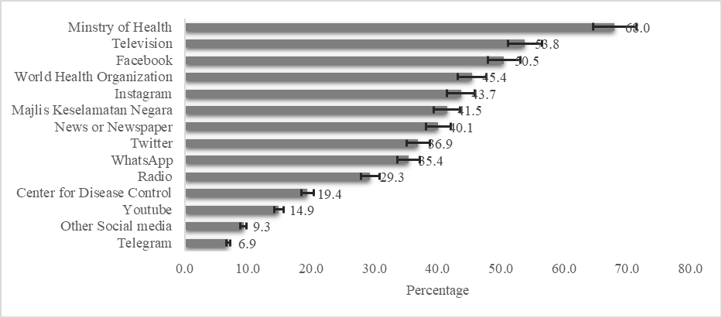
Fig 2. Sources of Information of COVID19 among adult population in Malaysia (n=743).

Distribution of knowledge, attitude and practice by age, sex, residence and ethnicity
Out of 743 respondents included in the cross-sectional study, the prevalence of good knowledge, positive attitude and frequent practice towards COVID-19 epidemic were found 52.6%, 51.8% and 57.1%, respectively. The prevalence of COVID-19 knowledge, attitude and practices score were 52.6%, 51.8% and 57.1% with Mean score 6.54 [SD: 1.38], 32.45 [SD: 4.29] and 32.0[4.92] respectively. Participant’s knowledge towards COVID-19 found to increase with the increase of age and persons aged 45 or above had more knowledge [67.9%] towards COVID-19. Females had found more knowledge [55.1%] where 46.5% found more knowledge towards COVID-19 among males. The participant whose ethnicity is Malay [54.1%] and living in urban [54.0%] areas had more knowledge [Fig 3(a)].
The participant’s positive attitude towards COVID-19 were found [55.7%] more in the age group 18-24 years and the negative attitude was highest [59.1%] among the people aged 45 and over. Females were showed more positive attitude than males [55.1 versus 53.5%]. The urban and participants whose ethnicity were Indian responded more positive attitude than others [Fig 3(b)].
Participant’s distribution of practice towards COVID-19 according to their age, sex, residence and ethnicity were presented in Fig 3(c). The participants aged 25 to 45 were more frequent [63.5%] in practice towards COVID-19 than any other age groups. Female participants [55.1%], urban [59.0%] and whose ethnicity were Indian [64.8%] found more frequent in practice towards COVID-19 [Fig 3(c)].
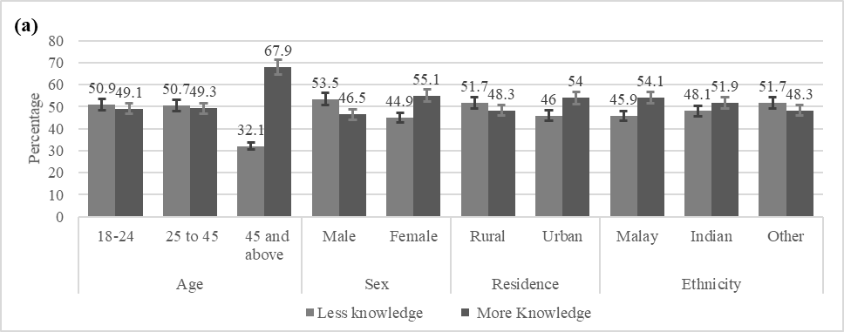
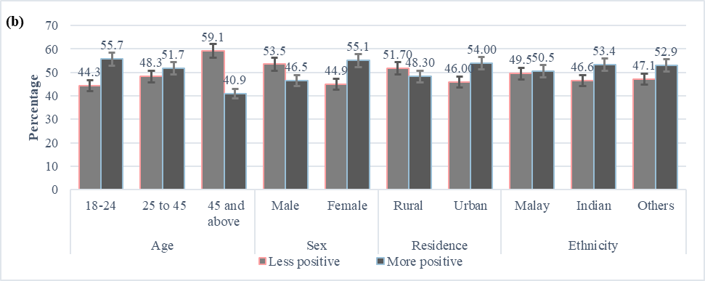
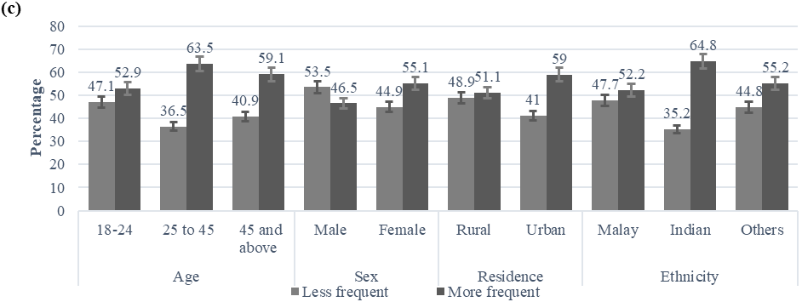

Fig 3. Respondent’s knowledge [3(a)], attitude [3(b)] and practice [3(c)] patterns towards COVID-19. The vertical axis represents percentage and parallel axis are the respondent’s age, sex, residence and ethnicity.

Socio-demographic association of knowledge, attitude and practices towards COVID-19
The association between participant’s socio-demographic factors with knowledge, attitude and practice were summarized in Table 2. The Pearson Chi-square test was performed to examine the significant associated factors of KAP. Respondent’s age, education and marital status were significantly [p<0.05] associated with participant’s knowledge. Participant’s age and gender were significantly [p<0.05] associated with the attitude towards COVID-19. Respondent’s sex and ethnicity were also significantly [p<0.05] associated with their practices towards COVID-19 (Table 1).
Table 1. Socio-demographic association of person’s knowledge, attitude and practices.
Socio-demographic factors |  |  | Knowledge (N=743) |  |  | Attitudes (N=743) |  |  | Practices (N=743)
 |  | Total | High knowledge n (%) | Low knowledge n (%) | P-value | Positive attitude n (%) | Negative attitude n (%) |  | Good n (%) | Poor n (%) | P-value
Age | 18-24 | 395 (53.2) | 233 (31.4) | 265(35.7) | 0.0001 | 277(37.3) | 221 (29.7) | .007 | 238 (32.0) | 260 (35.0) | 0.291
Age | 25-44 | 207 (27.9) | 76 (10.2) | 50 (6.7) | 0.0001 | 60 (8.1) | 66 (8.9) | .007 | 70 (9.4) | 56 (7.5) | 0.291
Age | >45 | 141 (19) | 82 (11.0) | 37 (5.0) | 0.0001 | 48 (6.5) | 71 (9.6) | .007 | 60 (8.1) | 59 (7.9) | 0.291
Gender | Male | 286 (38.5) | 157 (21.1) | 129(17.4) | 0.327 | 133(17.9) | 153 (20.6) | .022 | 106 (14.3) | 180 (24.2) | .000
Gender | Female | 457 (61.5) | 234 (31.5) | 223(30.0) | 0.327 | 252(33.9) | 205 (27.6) | .022 | 262 (35.3) | 195 (26.2) | .000
Residence | Rural | 180 (24.2) | 87 (11.7) | 93 (12.5) | 0.185 | 98 (13.2) | 82 (11.0) | 0.418 | 81 (10.9) | 99 (13.3) | 0.163
Residence | Urban | 563 (75.8) | 304 (40.9) | 259(34.9) | 0.185 | 287(38.6) | 276 (37.1) | 0.418 | 287 (38.6) | 276 (37.1) | 0.163
Ethnicity | Malay | 392 (52.8) | 212 (28.5) | 180(24.2) | 0.727 | 198(26.6) | 194 (26.1) | 0.732 | 170 (22.9) | 222 (29.9) | .002
Ethnicity | Chinese | 62 (8.3) | 31 (4.2) | 31(4.2) | 0.727 | 31 (4.2) | 31 (4.2) | 0.732 | 31 (4.2) | 31 (4.2) | .002
Ethnicity | Indian | 264 (35.5) | 137 (18.4) | 127(17.1) | 0.727 | 141(19.0) | 123 (16.6) | 0.732 | 155 (20.9) | 109 (14.7) | .002
Ethnicity | Others | 25 (3.4) | 11 (1.5) | 14 (1.9) | 0.727 | 415 (2.0) | 10 (1.3) | 0.732 | 12 (1.6) | 13 (1.7) | .002
Nationality | Malaysian | 726 (97.7) | 381 (51.3) | 345(46.4) | 0.605 | 374(50.3) | 352 (47.4) | 0.282 | 359 (48.3) | 367 (49.4) | 0.776
Nationality | Non- Malaysian | 17 (2.3) | 10 (1.3) | 7 (0.9) | 0.605 | 11 (1.5) | 6 (0.8) | 0.282 | 9 (1.2) | 8 (1.1) | 0.776
Education level | Uneducated | 3 (0.4) | 2 (0.3) | 1 (0.1) | 0.0165 | 2 (0.3) | 1 (0.1) | 0.828 | 257 (34.6) | 291 (39.2)
Education level | Primary | 1 (0.1) | 1 (0.1) | 0 (0.0) | 0.0165 | 1 (0.1) | 0 (0.0) | 0.828 | 34 (4.6) | 32 (4.3) | 0.72
Education level | Secondary | 35 (4.7) | 25 (3.4) | 10 (1.3) | 0.0165 | 17 (2.3) | 18 (2.4) | 0.828 | 158 (21.3) | 154 (20.7) | 0.72
Education level | Post-secondary | 156 (21) | 82 (11.0) | 74 (10.0) | 0.0165 | 83 (11.2) | 73 (9.8) | 0.828 | 4 (0.5) | 2 (0.3) | 0.72
Education level | Tertiary education | 548 (73.8) | 281 (37.8) | 267(35.9) | 0.0165 | 282 (38.0) | 266 (35.8) | 0.828 | 172 (23.1) | 187 (25.2) | 0.72
Occupation | Part time employed | 66 (8.9) | 36 (4.8) | 30 (4.0) | 0.14 | 36 (4.8) | 30 (4.0) | 0.099 | 34 (4.6) | 32 (4.3) | 0.72
Occupation | Full time employed | 312 (42) | 174 (23.4) | 138(18.6) | 0.14 | 145(19.5) | 167 (22.5) | 0.099 | 158 (21.3) | 154 (20.7) | 0.72
Occupation | Part time student | 6 (0.8) | 5 (0.7) | 1 (0.1) | 0.14 | 3 (0.4) | 3 (0.4) | 0.099 | 4 (0.5) | 2 (0.3) | 0.72
Occupation | Full time student | 359 (48.3) | 176 (23.7) | 183(24.6) | 0.14 | 201(27.1) | 158 (21.3) | 0.099 | 172 (23.1) | 187 (25.2) | 0.72
Marital Status | Single | 497 (66.9) | 240 (32.3) | 257(34.6) | .006 | 270(36.3) | 227 (30.6) | 0.10 | 238 (32.0) | 259 (34.9) | 0.549
Marital Status | Married | 224 (30.1) | 140 (18.8) | 84 (11.3) | .006 | 106(14.3) | 118 (15.9) | 0.10 | 120 (16.2) | 104 (14.0) | 0.549
Marital Status | Divorced | 11 (1.5) | 7 (0.9) | 4 (0.5) | .006 | 3 (0.4) | 8 (1.1) | 0.10 | 6 (0.8) | 5 (0.7) | 0.549
Marital Status | Widowed | 2 (0.3) | 1 (0.1) | 1 (0.1) | .006 | 2 (0.3) | 10 (0.0) | 0.10 | 1 (0.1) | 1 (0.1) | 0.549
Marital Status | Others | 9 (1.2) | 3 (0.4) | 6 (0.8) | .006 | 4 (0.5) | 5 (0.7) | 0.10 | 3 (0.4) | 6 (0.8) | 0.549
No. of family members | <5 | 311 (41.9) | 169 (22.7) | 142(19.1) | 0.077 | 165(22.2) | 146 (19.7) | 0.385 | 163 (21.9) | 148 (19.9) | 0.402
No. of family members | 5 to 8 | 385 (51.8) | 191 (25.7) | 194(26.1) | 0.077 | 192(25.8) | 193 (26.0) | 0.385 | 182 (24.5) | 203 (27.3) | 0.402
No. of family members | 8+ | 47 (6.3) | 31 (4.2) | 16 (2.2) | 0.077 | 28 (3.8) | 19 (2.6) | 0.385 | 23 (3.1) | 24 (3.2) | 0.402
Family income | <RM 4 849 | 256 (34.5) | 139 (18.7) | 117(15.7) | 0.639 | 142(19.1) | 114 (15.3) | 0.211 | 125 (16.8) | 131 (17.6) | 0.081
Family income | RM 4850 to 10959 | 318 (42.8) | 161 (21.7) | 157(21.1) | 0.639 | 164(22.1) | 154 (20.7) | 0.211 | 147 (19.8) | 171 (23.0) | 0.081
Family income | > RM 10 960 | 169 (22.7) | 91 (12.2) | 78 (10.5) | 0.639 | 79 (10.6) | 90 (12.1) | 0.211 | 96 (12.9) | 73 (9.8) | 0.081

Risk factors associated with Knowledge, Attitude and practice towards COVID-19
Participant’s socio-demographic risk factors were identified, observing the degree of association [odds ratio] obtained by an adjusted binary logistic regression model. Adjusted binary logistic regression analysis revealed that the odds of knowledge towards COVID-19 infections were 1.63 times higher in a person aged over 45 than those participants belonging in 18 - 24 years age group [AOR: 1.63, 95% CI: 0.81-3.27]. The other socio-demographic factors of more frequent knowledge were being tertiary education [AOR: 0.52, 95% CI: 0.24-1.13], being non- Malaysian (AOR: 1.34, 95% CI: 0.47-3.80), students [AOR: 1.25, 95% CI: 0.78-1.99], ever married [AOR: 1.40, 95% CI: 0.85-2.31]. The participants aged over 45, female, living in urban areas, Indian ethnic, post-secondary educated, students and had monthly > RM 10,960 income were more likely to practice towards COVID-19 (Table 3).

Table 2. Risk factors associated with Knowledge, attitude and practice for COVID-19 among general population.
Characteristics |  | Knowledge | Attitude | Practices
 |  | AOR (95% C.I.) | AOR | AOR
Age | 18 to 24 | Ref | Ref | Ref
Age | 25 to 45 | 0.92(0.56-1.51) | 0.72(0.43-1.25) | 1.9(1.09-3.31)
Age | >45 | 1.63(0.81-3.27) | 0.49(0.24-1.01) | 2.01(0.93-4.31)
Gender | Male | Ref | Ref | Ref
Gender | Female | 0.82(0.58-1.14) | 0.88(0.62-1.24) | 3.02(2.13-4.29)
Place | Rural | Ref | Ref | Ref
Place | Urban | 1.31(0.91-1.89) | 0.80(0.55-1.18) | 1.30(0.87-1.94)
Ethnicity | Malay | Ref | Ref | Ref
Ethnicity | Indian | 0.81(0.57-1.15) | 0.79(0.55-1.15) | 2.22(1.51-3.26)
Ethnicity | Other | 0.75(0.45-1.23) | 0.76(0.45-1.29) | 1.08(0.63-1.85)
Nationality | Malaysian | Ref | Ref | Ref
Nationality | Non-Malaysian | 1.34(0.47-3.80) | 1.94(0.63-5.92) | 1.99(0.55-7.24)
Education | School Education | Ref | Ref | Ref
Education | Post-Secondary Education | 0.56(0.25-1.28) | 0.75(0.33-1.70) | 1.58(0.68-3.65)
Education | Tertiary education | 0.52(0.24-1.13) | 0.89(0.42-1.93) | 0.91(0.42-1.98)
Occupation | Employed | Ref | Ref | Ref
Occupation | Students | 1.25(0.78-1.99) | 1.13(0.69-1.85) | 1.03(0.61-1.72)
Marital status | Single | Ref | Ref | Ref
Marital status | Ever married | 1.40(0.85-2.31) | 1.15(0.68-1.93) | 0.88(0.51-1.53)
Family member | <5 | Ref | Ref | Ref
Family member | 5 to 8 | 0.88(0.63-1.23) | 0.84(0.59-1.19) | 1.19(0.83-1.71)
Family member | >8 | 1.63(0.82-3.22) | 1.31(0.66-2.62) | 1.09(0.53-2.28)
Monthly Income | < RM4,849 | Ref | Ref | Ref
Monthly Income | RM4,850to RM10,959 | 0.84(0.59-1.19) | 0.99(0.69-1.43) | 0.84(0.57-1.22)
Monthly Income | > RM 10,960 | 0.73(0.47-1.13) | 0.70(0.45-1.11)) | 1.87(1.14-3.03)

Degree of practices based on participant’s knowledge and attitude
Participant’s degree of practices was determined based on their knowledge and attitude obtained by adjusted binary logistic regression model (Table 4). It was investigated that the participants who were belonging to more knowledge were significantly more [AOR: 1.50; 95% CI: 1.11-2.03] likely to practice towards COVID-19. Again, the participants who were more positive in attitude, were significantly 3.03 [AOR: 2.03; 95% CI: 2.24-4.10] times more likely to practice towards COVID-19.
Table 3. Degree of practices based on the participant’s knowledge and attitude.
Characteristics |  | AOR(95% CI)
Knowledge | Less knowledge | Reference category
Knowledge | More knowledge | 1.50 (1.11-2.03)
Attitude | Less positive | Reference category
Attitude | More positive | 3.03 (2.24-4.10)

Prevalence of knowledge, attitude and practice behaviors in Southeast and South Asia obtained by systematic review
Our meta-analysis included 18 articles from 11 countries of South and Southeast Asia. Most of the studies were conducted in Nepal (n=3) and only one study found in Afghanistan. All the selected studies were conducted within the year of 2020. The minimum sample size was 368, conducted in Indonesia and maximum sample size was 4850 in Malaysia. Among the selected 18 studies, 13 reported prevalence of knowledge and five reported a mean score of knowledge towards COVID-19. The prevalence of knowledge towards COVID-19 were ranged 26.53% (minimum: Thailand) to 95.4% (maximum: Nepal). However, almost all studies reported more than 50% knowledge prevalence rate in COVID-19 (Table 4). Overall, the pooled prevalence of good knowledge towards COVID-19 was 0.79 (95% CI: 0.69-0.89) whereas the value was 0.84 in South Asia and 0.72 (95% CI: 0.50-0.93) in Southeast Asia respectively, obtained by subgroup analysis. The heterogeneity of knowledge prevalence was 96.77% and the prevalence difference between Southeast and South Asia was insignificant (p=0.31) (Fig 4).
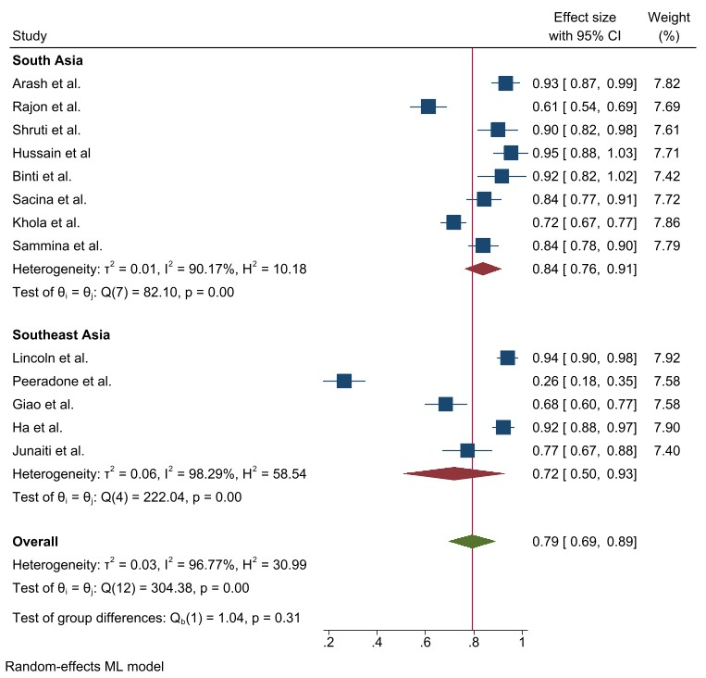
Fig 4. Prevalence of good knowledge towards COVID-19 epidemic in Southeast and South Asia, stratified by region.

The attitude towards COVID-19 was also found satisfactory in South and Southeast Asia. Similar to knowledge, the attitude prevalence was also found more than 50% in all the selected studies where the maximum positive attitude showed in 92.5% in Pakistan and the minimum was in Turkey (59.3%). The pooled prevalence of positive attitude was 0.80 (95% CI: 0.75-0.84) and this value was higher (0.83 vs. 0.77) in South Asia compared to Southeast Asia. Heterogeneity was 90.27% among the study and the prevalence difference between Southeast and South Asia was insignificant (p=0.19) (Fig 5)
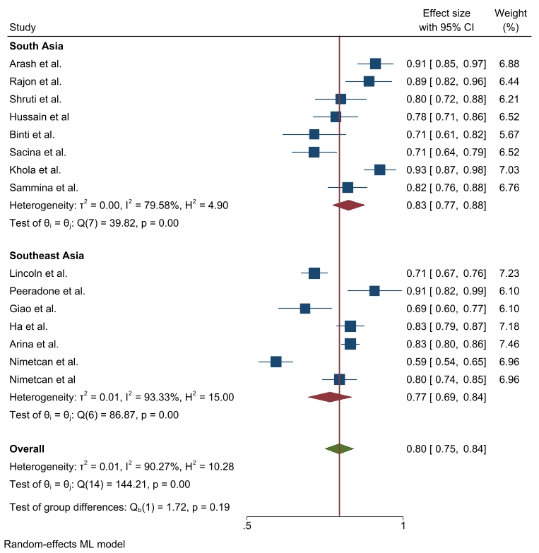
Fig 5. Prevalence of positive attitude towards COVID-19 epidemic in Southeast and South Asia, stratified by region.

In the case of COVID-19 prevention practice, the prevalence was also satisfactory. The maximum prevalence towards COVID-19 prevention practice was found at 97% in Afghanistan where the minimum value was 50.2% in Turkey (Table 4). According to random effect model, the pooled prevalence of frequent practice towards COVID-19 epidemic was 0.83 where this practice was insignificantly different between South Asia and Southeast Asia (0.85 vs. 0.83; p=0.52), obtained by subgroup analysis. The heterogeneity was 96.98% among the studies (Fig 6).
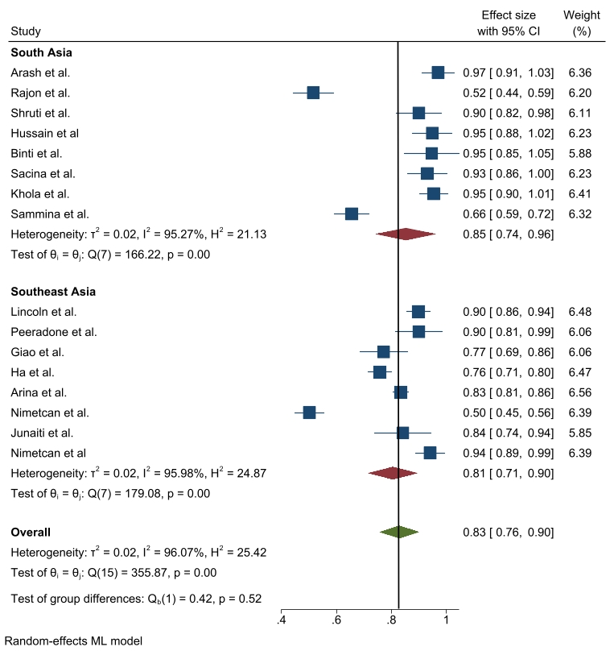
Fig 6. Prevalence of frequent practice towards COVID-19 epidemic in Southeast and South Asia, stratified by region.

Five studies reported mean scores instead of the prevalence knowledge towards COVID-19, where the mean value ranged from 8.15±1.6 (minimum: Turkey) to 13.14±2.76 (maximum: Indonesia). Four studies reported mean attitude score instead of prevalence and the mean value ranged between 2.33±0.66 (minimum: India) and 33.0±2.7 (maximum: Indonesia). Only three studies reported a mean score of prevention practice towards COVID-19, where the minimum score was reported in India (1.97±0.16) and the maximum was in Indonesia (31.03±3.80).
Study bias was examined by funnel plot and the bias was present in all knowledge, attitude and practice (Supporting information S1-S3).

Factors associated with COVID-19 patient’s knowledge, attitude and practice obtained by Systematic review
In our selected studies, almost all authors reported risk factors of knowledge, attitude and practice towards COVID-19. The maximum number of risk factors were observed in the study from Nepal, Malaysia and Turkey, whereas the most frequent risk factors were participant’s age, gender, education, place of residence and occupation (Table 4).
Table 4: Characteristics of studies included in the systematic review of knowledge, attitude and practice toward COVID-19 in Southeast and South Asia.
Author | Country | Sample | Time | Significant Factor | Knowledge (%) | Attitude (%) | Practice (%)
Arash et al.,[22] | Afghanistan | 1169 | Oct. 2020 | ----- | 93.2% | 91.1% | 97%
Rajon et al.,[23] | Bangladesh | 707 | May.2020 | Gender, Education, Place of residence | 61.2% | 89.0% | 51.6%
Shruti et al.,[24] | India | 570 | July, 2020 |  | 90.0% | 80.0% | 90.0%
Hussain et al., [25] | Nepal | 760 | April, 2020 | Gender, Occupation | 95.4% | 78.4% | 94.9%
Binit et al., [26] | Nepal | 380 | April, 2020 |  | 91.6% | 71.5% | 94.7%
Sachina et al.,[27] | Nepal | 766 | Mar.-Apr. 2020 | age, marital status, gender, education, occupation, province of residence | 84.3% | 71.5% | 93.1%
Khola et al.,[28] | Pakistan | 1474 | June, 2020 | Gender, Education | 71.7% | 92.5% | 95.4%
Sammina et al., [29] | Pakistan | 1000 |  | Gender, Education, Income | 83.9% |  | 65.6%
Lincoln et al.,[14] | Philippine | 2224 | Feb-Mar., 2020 | Place of Residence, Education | 94.0% | 82.2% | 89.9%
Peeradone et al.,[30] | Thailand | 520 | Feb, 2020 | Gender, Age, Education | 26.53% | 71.5% | 90.0%
Giao et al.,[31] | Vietnam | 522 | Feb.-Mar. 2020 | Gender, Knowledge level, Education, Age | 68.4% | 90.8% | 77.2%
Ha et al.,[32] | Vietnam | 1999 | April, 2020 | Age, Sex, marital Status, Fear | 92.2% | 68.6% | 75.8%
Arina et al., [33] | Malaysia | 4850 | Mar.-Apr.2020 | Gender, Age, Region, Occupation, Income | 10.5±1.4 (13) | 83.1% | 83.4%
Nimetcan et al.,[34] | Turkey, Malaysia | 1320 | April, 2020 | Gender, Education, Age, marital Status | 8.15±1.6  9.99±1.8 | 59.3%, 79.6% | 50.2%, 94.1%
Junaiti et al.,[35] | Indonesia | 368 | June, 2020 | Source of information, Gender, Working Status, | 77.4% | 33.0±2.7 | 84.2%
Mohammad et al.,[36] | Bangladesh | 2157 | Apr.-May.2020 | Age, Education, Place of residence | 8.71 ±1.64 (12) | 8.9 ±1.2 (12) | 8.7 ±1.6 (12)
Himali et al.,[37] | India | 1231 | Apr.-May,2020 | Gender, Occupation | 10.19±1.6 (12) | 2.33±0.66 (3) | 1.97±0.16 (2)
Muhammad et al.,[38] | Indonesia | 6249 | Apr-May,2020 | Gender, Place of Residence, Occupation, Major of education | 13.14±2.76 (18) | 16.56±1.72 | 31.06±3.80

Discussion
This mixed–methodological research is one of the limited studies devoted to COVID-19 so far in the context of Malaysia and other Southeast and South-Asian countries. Globally, COVID-19 has catastrophic consequences in all sectors in a short period since its emergence. Health officials have placed stringent lockdowns, shelters in place, or MCO on their inhabitants in order to control the transmission of the virus. The effectiveness of these management techniques is largely contingent on citizen involvement and compliance. Moreover, the risk factors associated with KAP of this novel disease among people is necessary to investigate in order to specify the target groups where interventions are needed for behavioral change. There is currently little information available on the KAP towards COVID-19 in a complete form in Southeast and South Asia. Thus, it's critical to evaluate Southeast and South-Asian KAP and the factors that influence it in order to devise effective methods to prepare and manage the individuals.

According to cross-sectional result findings, the Ministry of Health was the most preferred source of information for COVID-19, followed by television, Facebook, and WHO, respectively. The Malaysian government also created a Telegram channel that was approved by the "Ministry of Health Malaysia and Malaysia Communications and Multimedia Commission (MCMC)". This attempt by the government to monitor the dissemination of false information about COVID-19 could explain why the Ministry of Health was the most favored source of information [1,39]. In response to COVID-19, different countries in Southeast and South Asia has raised an alert and implemented wide-ranging, multiagency public health measures under WHO guidelines to fight against the pandemic. As COVID-19 appears to be transmitted from person to person through respiratory droplets, close contact, and fomites in the immediate environment around the infected person, almost all countries in Southeast and South Asia initiated a public campaign highlighting the necessity of practicing respiratory hygiene and hand hygiene and using appropriate personal protective equipment (PPE) such as mask and gloves, with evidence of minimal adoption by the public at large [12-17, 22, 24, 40].

Despite the fact that the majority of our sample participants had completed their tertiary education which is shown in our cross-sectional study and it has been over a year since COVID-19 was first introduced in Malaysia, our survey shown only half of the population had good knowledge level of COVID-19. This finding is lower than that of our meta-analysis and a previous study conducted in Malaysia [1]. Similar study conducted in Nigeria showed that almost all of the participants had good knowledge of COVID-19, whereas survey conducted in Qatar and Iran revealed high prevalence of having good knowledge of COVID-19 [41–43]. While, a low percentage of the Bangladeshis, Indians and Saudi Arabians population had good knowledge and the findings are almost close to our study [44–46]. The findings of this mixed study supports the above literature.

The study found that individuals of age >45 years had more likely to have COVID-19 knowledge than younger persons (18-45 years of age). A study conducted in Saudi Arabia also showed that older individuals had higher knowledge about COVID-19 [47]. According to the World Health Organization (WHO) and some previous studies, older society is at the highest risk of contracting this virus, and more than 95% of the related death is attributed to this group [48,49]. This may be because older people are more likely to catch viruses or diseases such as COVID-19 due to poor immunity, so they could be more cautious about COVID-19. In addition, our study showed that non-Malaysian, students and married citizens have more knowledge than their counterparts. Similar research carried out in Malaysia also showed that knowledge was significantly related to age, schooling and job status [1]. Our findings of knowledge are also concordant with the studies conducted in Pakistan and China in which knowledge score was significantly different among age groups, marital status, level of education and employment status [50,51].

As far as attitudes are concerned, almost half of the participants demonstrated a positive attitude towards coronavirus in our cross-sectional research and the level was high in Southeast and South Asia obtained by meta-analysis. People aged 25-45, women, urban people, Indian ethnicity, tertiary education, and monthly income between RM 4, 850, and 10,959 are less likely to have a positive attitude towards COVID-19 epidemic. Women may also seek a greater understanding on COVID-19 to overcome the greater sensitivity to danger and attendant stress reported in women than men [17]. The WHO South-East Asia region country profile and the IEDCR COVID-19 update state that the number of deaths is higher among elderly persons, males, and those with pre-existing co-morbidities in Bangladesh [52]. Non-Malaysian, students, married and having >8 family members were more likely to have a positive attitude against COVID-19. In the previous Malaysian survey, similar results were found that 83% of participants had favorable attitudes towards the regulation of COVID-19 and the attitudes markedly correlated with age, religion and profession [1]. However, some studies showed negative emotions like panic and anxiety during a pandemic that could influence their attitudes [51,53, 61]. One study in China showed fear related to age concerning knowledge and occupation, while another study completed in India reported that 80% of people in need of mental health care for COVID-19 experienced fear, anxiety, and depression [51,54].

Despite the WHO and countries are emphasizing on the general public to practice COVID-19 preventive measures, in our study, above half of the participants showed good practice level towards COVID-19. Our study also highlighted that age >45 years, female gender, urban residents, Indian ethnicity, non-Malaysian, higher education, students, ever married and good income were more likely to have good practice and all are significant to COVID-19 preventive measures in Malaysia. By systematic review, we observed significant association between good practice towards COVID-19 and age, gender, region and occupation [1, 12-17]. Hence, these findings suggest that health education interventions targeting particular groups such as younger people, men, people with low education, and people with a less monthly income, rural residents, and ethnic groups other than Indian should be designed in order to improve COVID-19 awareness, which can play vital role in improving the practice of individual’s preventive attitudes [1,12,16]. It is a common consensus that a more educated population about any given disease will comply better with the preventive and treatment measures [55]. In our research, we also discovered that people who had positive practice toward COVID-19 had higher levels of knowledge and higher chances of having an appropriate attitude. Similar findings have been observed in a KAP survey for COVID-19 [1,56–58]. Women are more likely to wear a mask when leaving home compared to men [38]. However, men were also less likely to go to a crowded place compared to women; this result contradicted the finding of a previous study that men were more likely to engage in risk-taking behavior [59]. Our finding is consistent with that of a study conducted in China that found a significant association between men and potentially dangerous practices toward COVID-19, including going to a crowded place during the pandemic or not wearing a mask when leaving home [51].

This study offers several implications for the practitioners, governments and health agencies not only regarding the COVID-19 but also for the upcoming disease. Firstly, this study helps countries to know about individuals KAP level; it can assist them to design different awareness programs. Besides, it also helps which group of the individuals requires more attention, such as people less than 24 years, male, living in rural areas, single, and less family income. Secondly, the present study reveals that government not only have to design the awareness but also control mechanism must be developed for monitoring perspective. In addition, non-governmental agencies must participate in the awareness program since people living in rural areas have poor knowledge, attitude and adopted practices. Finally, the government must advised strictly prohibit people not to shake hands, avoid hugs and keep social distancing.

There are some flaws in our research. Firstly, when the research was done online, individuals who did not have access to the internet were not able to participate. Consequently, results could not apply to the whole population. Secondly, since it was an online survey, there was a possibility of reporting bias. However, we conclude that our survey provides valuable insight into Malaysian viewpoints and the effect of the COVID-19 pandemic on the Malaysian community. Therefore, the results can be used by health officials to develop outreach programs and health strategies.

Conclusions
Overall, KAP associated to COVID-19 among the participants were roughly evidenced appropriately. The prevalence of high knowledge, positive attitude and good practice towards COVID-19 were found 26.53-95.4%, 59.3%-92.5%, and 50.2%-97.0%, respectively among the Southeast and South Asian population. The cross-sectional study showed that having more knowledge and attitude were encourage more likely to practice towards COVID-19. Higher aged people, female, urban residents, Indian ethnic and tertiary education are significant factors to KAP towards COVID-19 in Southeast and South Asia. The systematic review results can be used to inform that how others countries in south Asia and south-east Asia enrich their knowledge during the pandemic. The findings of this mixed study conducted on separate background respondents may be helpful for health professionals and policymakers to develop targeted interventions and effective practices. A comprehensive awareness-raising program through mass media as well as the internet and social media is urgently required with parallel with government awareness program for the general people to learn and understand the seriousness of the outbreak.

Conflict of interest
The authors declared no conflict of interest.
Funding
This study received no funding from any organization or agencies.

Reference
1. Azlan AA, Hamzah MR, Sern TJ, Ayub SH, Mohamad E. Public knowledge, attitudes and practices towards COVID-19: A cross-sectional study in Malaysia. PLoS One. 2020 May 1;15(5):e0233668. pmid: 32437434
2. Ahammed T, Anjum A, Rahman MM, Haider N, Kock R, Uddin MJ. Estimation of novel coronavirus (COVID-19) reproduction number and case fatality rate: A systematic review and meta-analysis. Heal Sci Reports. 2021 Jun;4(2):e274. pmid: 33977156
3. Haque MF, Rahman MM, Alif SM, Akter E, Barua S, Paul GK, et al. Estimation and prediction of doubling time for COVID-19 epidemic in Bangladesh: a modelling study of first 14 month’s daily confirmed new cases and deaths. Glob Biosecurity. 2021;3(2). https://doi.org/10.31646/gbio.91
4. Rahman, MM Bhattacharjee B, Farhana Z, Hamiduzzaman, M Chowdhury M, Hossain M, Siddiqee M, Islam Z, et al. Age-related risk factors and severity of SARS-CoV-2 infection: a systematic review and meta-analysis. J Prev Med Hyg. 2021;62:E329–71. https://doi.org/10.15167/2421-4248/jpmh2021.62.2.1946
5. WHO. Weekly operational update on COVID-19. 2021. Available from: https://www.who.int/publications/m/item/weekly-operational-update-on-covid-19---28-september-2021
6. Reuters. Malaysia confirms first cases of coronavirus infection. 2020. Available from: https://www.reuters.com/article/china-health-malaysia/malaysia-confirms-first-cases-of-coronavirus-infection-idUSL4N29U03A
7. Times N straits. Malaysia records first two Covid-19 deaths; cases soar to 673. 2020. Available from: https://www.nst.com.my/news/nation/2020/03/575451/malaysia-records-first-two-covid-19-deaths-cases-soar-673
8. WHO. Malaysia: WHO Coronavirus Disease (COVID-19) Dashboard with Vaccination Data. 2021. Available from: https://covid19.who.int/region/wpro/country/my
9. Hasan MN, Haider N, Stigler FL, Khan RA, McCoy D, Zumla A, et al. The Global Case-Fatality Rate of COVID-19 Has Been Declining Since May 2020. Am J Trop Med Hyg. 2021 Jun 1;104(6):2176. pmid: 33882025
10. Fernandes N. Economic Effects of Coronavirus Outbreak (COVID-19) on the World Economy. SSRN Electron J. 2020 Mar 22. https://doi.org/10.2139/SSRN.3557504
11. Mohamad E, Azlan AA. COVID-19 and communication planning for health emergencies. Vol. 36, Jurnal Komunikasi: Malaysian Journal of Communication. 2020. Available from: https://pesquisa.bvsalud.org/global-literature-on-novel-coronavirus-2019-ncov/resource/en/covidwho-828809
12. Nadeeya ‘Ayn Umaisara Mohamad Nor, Hana Maizuliana Solehan, Nurul Azmawati Mohamed, Zatul Iffah Abu Hasan, Nur Syazana Umar, Suhaila Sanip, et al. Knowledge, attitude and practice (KAP) towards COVID-19 prevention among Malaysian adults during the period of Movement Control Order (MCO): An online cross-sectional survey. IJRPS. 2020 Dec 15;11(SPL1):1458–68. https://doi.org/10.26452/IJRPS.V11ISPL1.3693
13. Qalati SA, Ostic D, Fan M, Dakhan SA, Vela EG, Zufar Z, et al. The General Public Knowledge, Attitude, and Practices Regarding COVID-19 during the Lockdown in Asian Developing Countries. 2021 Apr 8. pmid: 33832371
14. Lau LL, Hung N, Go DJ, Ferma J, Choi M, Dodd W, et al. Knowledge, attitudes and practices of COVID-19 among income-poor households in the Philippines: A cross-sectional study. J Glob Health. 2020;10(1). pmid: 32566169
15. CL W, J C, KM C, BMH L, DNS C, WKW S, et al. Knowledge, Attitudes and Practices Towards COVID-19 Amongst Ethnic Minorities in Hong Kong. Int J Environ Res Public Health. 2020 Nov 1;17(21):1–13. pmid: 33121143
16. Ferdous MZ, Islam MS, Sikder MT, Mosaddek ASM, Zegarra-Valdivia JA, Gozal D. Knowledge, attitude, and practice regarding COVID-19 outbreak in Bangladesh: An online-based cross-sectional study. PLoS One. 2020 Oct 1;15(10):e0239254. pmid: 33035219
17. Sulistyawati S, Rokhmayanti R, Aji B, Wijayanti SPM, Hastuti SKW, Sukesi TW, et al. Knowledge, attitudes, practices and information needs during the covid-19 pandemic in indonesia. Risk Manag Healthc Policy. 2021 Jan 14;14:163–75. pmid: 33488129
18. Alrasheed MM, Alshahrani AH, Almuhaini SA, Alkofide HA, Alhawassi TM, Aldemerdash A, et al. Knowledge, attitude, and practice towards covid-19 among pharmacists: A cross-sectional study. Risk Manag Healthc Policy. 2021 Jul 23;14:3079–90. pmid: 34326673
19. Kaliyaperuma K. Guideline for Conducting a Knowledge, Attitude and Practice (KAP) Study. Community Ophthalmol. 2004;IV(1):7–9. Available from: http://v2020eresource.org/content/files/guideline_kap_Jan_mar04.pdf
20. Rahman M, Hamiduzzaman M, Akter M, Farhana Z, Hossain M, Hasan M, et al. Frailty indexed classification of Bangladeshi older adults’ physio-psychosocial health and associated risk factors- a cross-sectional survey study. BMC Geriatr. 2021;21(1):3. pmid: 33402094
21. Paul GK, Rahman MM, Hamiduzzaman M, Farhana Z, Mondal SK, Akter S, et al. Hypertension and its physio-psychosocial risks factors in elderly people: a cross-sectional study in north-eastern region of Bangladesh. J Geriatr Cardiol. 2021 Jan;18(1):75–82. pmid: 33613661
22. A N, N R, MF S, AR R, A A. Knowledge, Attitudes, and Practices of Medical Students Regarding COVID-19 in Afghanistan: A Cross-Sectional Study. Risk Manag Healthc Policy. 2021;14:1491–7. pmid: 33883955
23. Banik R, Rahman M, Sikder MT, Rahman QM, Pranta MUR. Knowledge, attitudes, and practices related to the COVID-19 pandemic among Bangladeshi youth: a web-based cross-sectional analysis. J Public Heal 2021. 2021 Jan 16;1–11. pmid: 33489718
24. Shukla S, Deotale P. Knowledge, attitude and practices towards COVID-19 pandemic in the community: a cross-sectional web-based survey in India. Int J Res Med Sci. 2020 Sep 24 [cited 2021 Sep 11];8(10):3652–6. https://doi.org/10.18203/2320-6012.IJRMS20204246
25. Hussain A, Garima T, Singh BM, Ram R, Tripti RP. Knowledge, attitudes, and practices towards COVID-19 among Nepalese Residents: A quick online cross-sectional survey. Asian J Med Sci. 2020 May 1;11(3):6–11. https://doi.org/10.3126/AJMS.V11I3.28485
26. Vaidya B, Bhochhibhoya M, Baral R, Nakarmi S. Knowledge, attitudes, and practice regarding covid-19 among patients with musculoskeletal and rheumatic diseases in nepal: A web-based cross-sectional study. Open Access Rheumatol Res Rev. 2020 Aug 21;12:167–73. pmid: 32904652
27. Paudel S, Shrestha P, Karmacharya I, Pathak OK. Knowledge, attitude, and practices (KAP) towards COVID-19 among Nepalese residents during the COVID-19 outbreak: An online cross-sectional study. 2020 Jun 9. https://doi.org/10.21203/RS.3.RS-31044/V1
28. K N, ZE R, M U, R R, M B, F B. Knowledge, attitudes, and practices against the growing threat of COVID-19 among medical students of Pakistan. PLoS One. 2020 Dec 1;15(12). pmid: 33306712
29. Mahmood S, Hussain T, Mahmood F, Ahmad M, Majeed A, Beg BM, et al. Attitude, Perception, and Knowledge of COVID-19 Among General Public in Pakistan. Front Public Heal. 2020 Dec 9;0:861. pmid: 33363092
30. Srichan P, Apidechkul T, Tamornpark R, Yeemard F, Khunthason S, Kitchanapaiboon S, et al. Knowledge, attitudes and preparedness to respond to COVID-19 among the border population of northern Thailand in the early period of the pandemic: a cross-sectional study. WHO South-East Asia J Public Heal. 2020;9(2). pmid: 32978344
31. Huynh G, Nguyen MQ, Tran TT, Nguyen VT, Nguyen TV, Do THT, et al. Knowledge, attitude, and practices regarding covid-19 among chronic illness patients at outpatient departments in Ho Chi Minh City, Vietnam. Risk Manag Healthc Policy [Internet]. 2020 Sep 14;13:1571–8. pmid: 32982515
32. H VN, TT T-H, NTA V, TNQ L, TQ T. Knowledge, Attitudes, and Practices of the Vietnamese as Key Factors in Controlling COVID-19. J Community Health. 2020 Dec 1;45(6):1263–9. pmid: 32894387
33. Azlan AA, Hamzah MR, Sern TJ, Ayub SH, Mohamad E. Public knowledge, attitudes and practices towards COVID-19: A cross-sectional study in Malaysia. PLoS One. 2020 May 1;15(5):e0233668. pmid: 32437434
34. Mehmet N, Al-Abed A abed AA, Gökler ME, Elengoe A, Ünal E, Mollahaliloğlu S. Knowledge, attitudes and practices regarding COVID-19 among the Turkish and Malaysian general populations during lockdown: A cross-sectional online survey. Ethiop J Heal Dev. 2020;34(4):243–52. Available from: https://www.ajol.info/index.php/ejhd/article/view/203220
35. Sahar J, Kiik SM, Wiarsih W, Rachmawati U. Coronavirus Disease-19: Public Health Nurses’ Knowledge, Attitude, Practices, and Perceived Barriers in Indonesia. Open Access Maced J Med Sci. 2020 Oct 23;8(T1):422–8. https://doi.org/10.3889/oamjms.2020.5446
36. Hossain MA, Jahid MIK, Hossain KMA, Walton LM, Uddin Z, Haque MO, et al. Knowledge, attitudes, and fear of COVID-19 during the Rapid Rise Period in Bangladesh. PLoS One. 2020 Sep 1;15(9):e0239646. pmid: 32970769
37. Vyas H, Goyal R, Meena JK, Mathur M, Yadav A. Knowledge, attitude, and practices in response to COVID-19 pandemic in Indian population. Int J Res Med Sci. 2020 Oct 28;8(11):4038–46. https://doi.org/10.18203/2320-6012.IJRMS20204900
38. M M, HD S, YA R, MH C. Knowledge, Attitude, and Practice of Indonesian Residents toward COVID-19: A Cross-Sectional Survey. Int J Environ Res Public Health. 2021 May 1;18(9). pmid: 33922420
39. The Star. Covid-19: MCMC launches Telegram channel for anti-fake news portal Sebenarnya.my. 2021. Available from: https://www.thestar.com.my/tech/tech-news/2020/03/16/covid-19-mcmc-launches-telegram-channel-for-anti-fake-news-portal-sebenarnyamy
40. Banik R, Rahman M, Sikder T, Gozal D. COVID-19 in Bangladesh: public awareness and insufficient health facilities remain key challenges. Public Health. 2020 Jun 1;183:50. pmid: 32428773
41. Moradzadeh R, Nazari J, Shamsi M, Amini S. Knowledge, Attitudes, and Practices Toward Coronavirus Disease 2019 in the Central Area of Iran: A Population-Based Study. Front Public Heal. 2020 Dec 8;0:862. pmid: 33364226
42. Reuben RC, Danladi MMA, Saleh DA, Ejembi PE. Knowledge, Attitudes and Practices Towards COVID-19: An Epidemiological Survey in North-Central Nigeria. J Community Health [Internet]. 2021 Jun 1;46(3):1. pmid: 32638198
43. A B, A A-K. Knowledge, attitude and practice towards SARS. J R Soc Promot Health. 2004 Jul;124(4):167–70. https://doi.org/10.1177/146642400412400408
44. Paul A, Sikdar D, Hossain MM, Amin MR, Deeba F, Mahanta J, et al. Knowledge, attitudes, and practices toward the novel coronavirus among Bangladeshis: Implications for mitigation measures. PLoS One. 2020 Sep 1;15(9):e0238492. pmid: 32877449
45. A A, R E-S, M A, M E-S. Knowledge and attitudes towards Middle East respiratory sydrome-coronavirus (MERS-CoV) among health care workers in south-western Saudi Arabia. East Mediterr Health J. 2020 Apr 1;26(4):435–42. https://doi.org/10.26719/emhj.19.079
46. Singh JP, Sewda A, Shiv DG. Assessing the Knowledge, Attitude and Practices of Students Regarding the COVID-19 Pandemic. 2020 Aug 11;22(2):281–90. https://doi.org/10.1177/0972063420935669
47. Al-Hanawi MK, Angawi K, Alshareef N, Qattan AMN, Helmy HZ, Abudawood Y, et al. Knowledge, Attitude and Practice Toward COVID-19 Among the Public in the Kingdom of Saudi Arabia: A Cross-Sectional Study. Front Public Heal. 2020 May 27;0:217. pmid: 32574300
48. Kluge DHHP. Statement – Older people are at highest risk from COVID-19, but all must act to prevent community spread. World Heal Organ. 2020 Sep 10;7–10. Available from: https://www.euro.who.int/en/health-topics/health-emergencies/coronavirus-covid-19/statements/statement-older-people-are-at-highest-risk-from-covid-19,-but-all-must-act-to-prevent-community-spread
49. Haider N, Yavlinsky A, Chang Y-M, Hasan MN, Benfield C, Osman AY, et al. Epidemiology and Infection The Global Health Security index and Joint External Evaluation score for health preparedness are not correlated with countries’ COVID-19 detection response time and mortality outcome. [cited 2021 Sep 10]; pmid: 32892793
50. Afzal MS, Khan A, Qureshi UUR, Saleem S, Saqib MAN, Shabbir RMK, et al. Community-Based Assessment of Knowledge, Attitude, Practices and Risk Factors Regarding COVID-19 Among Pakistanis Residents During a Recent Outbreak: A Cross-Sectional Survey. J Community Health. 2021 Jun 1;46(3):1. pmid: 32661860
51. Zhong BL, Luo W, Li HM, Zhang QQ, Liu XG, Li WT, et al. Knowledge, attitudes, and practices towards COVID-19 among chinese residents during the rapid rise period of the COVID-19 outbreak: A quick online cross-sectional survey. Int J Biol Sci. 2020;16(10):1745–52. pmid: 32226294
52. WHO. Morbidity and Mortality Weekly Update No57. 2021. Available from: https://www.who.int/publications/i/item/10665332639
53. RJ B, JM B, CM D, E R, K T-C. The public’s response to severe acute respiratory syndrome in Toronto and the United States. Clin Infect Dis. 2004 Apr 1;38(7):925–31. https://doi.org/10.1086/382355
54. D R, S T, SK K, N S, SK V, V K. Study of knowledge, attitude, anxiety & perceived mental healthcare need in Indian population during COVID-19 pandemic. Asian J Psychiatr. 2020 Jun 1;51. pmid: 32283510
55. Hocking A, Laurence C, Lorimer M. Patients’ knowledge of their chronic disease: The influence of socio-demographic characteristics. Aust Fam Physician. 2013;42(6):411–6. pmid: 23781550
56. Li Z-H, Zhang X-R, Zhong W-F, Song W-Q, Wang Z-H, Chen Q, et al. Knowledge, attitudes, and practices related to Coronavirus disease 2019 during the outbreak among workers in China: A large cross-sectional study. PLoS Negl Trop Dis. 2020 Sep 1;14(9):e0008584. pmid: 32941447
57. D P, F M, DG R, IV P, EC F, Z D, et al. Assessment of Knowledge, Attitudes, and Practices towards New Coronavirus (SARS-CoV-2) of Health Care Professionals in Greece before the Outbreak Period. Int J Environ Res Public Health. 2020 Jul 2;17(14):1–14. pmid: 32650614
58. Lee M, Kang B-A, You M. Knowledge, attitudes, and practices (KAP) toward COVID-19: a cross-sectional study in South Korea. BMC Public Heal 2021 211. 2021 Feb 5;21(1):1–10. pmid: 33546644
59. Cobey KD, Stulp G, Laan F, Buunk AP, Pollet T V. Sex differences in risk taking behavior among dutch cyclists. Vol. 11, Evolutionary Psychology. 2013;p. 350–64. pmid: 23674522
60. Kumar Paul G, Rahman M, Naznin S, Haq Chowdhury M, Jamal Uddin M. Depression and Anxiety among University Students: a Comparison Between COVID-19 Pandemic Panic Period and Post-Panic Period in Bangladesh. 2021. https://doi.org/10.21203/rs.3.rs-702997/v1

